
CART TRACK
INSTALLATION & USER MANUAL
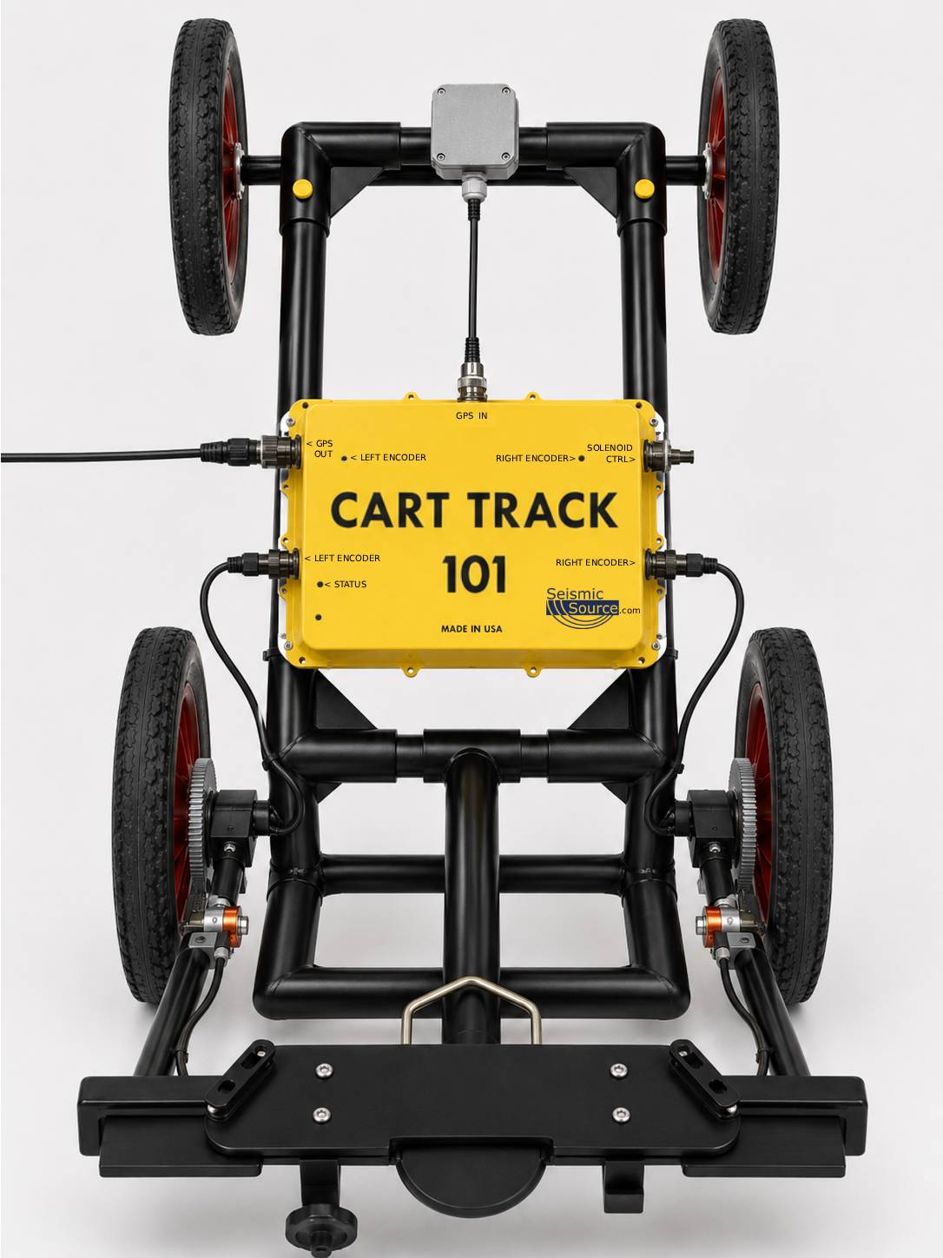

DOCUMENT AND PRIVACY INFORMATION

Seismic Source Company
Printed in the U.S.A.
©2026 Seismic Source Company. All rights reserved.
No portion of this document may be reproduced, stored, or transmitted in any form without the prior written consent of Seismic Source Company.
Seismic Source Company reserves the right to modify or improve its products and documentation without prior notice.

MANUAL CONTENTS

GETTING STARTED  MAIN TAB  CALIBRATION TAB | External GNSS Tab  SOLENOID TAB - SEISMIKE  SUPPORT
  Cart Track Overview | 4
  Hardware Setup | 5
  Connect to Cart Track | 6-7
  Main Tab Overview | 8
  Encoder - Indoor Operation | 8
  Encoder Configuration | 9
  GPS Passthrough - Outdoor Operation | 10
  Position Map | 11
  Actions | 11
  Firmware Update | 11
  Calibration Tab Overview | 12
  Rollup Calibration | 12
  Wheelbase Calibration | 13
  Current Values | 13
  Manual Override | 13
  External GNSS Tab | 16
  NMEA | 16
  SSC GNSS | 16
  Settings | 16
  Solenoid Tab Overview | 17
  Solenoid Control (SSR) | 17
  Pulse Width | 17
  Sync TTL Output | 18
  Sync Pulse Width | 18
  Pre-start Delay | 18
  Fire Control | 19
  Manual Only | 19
  Distance Interval | 19
  Time Interval | 19
  Troubleshooting and Support | 20
NETWORK TAB
Network Tab Overview | 14
Wi-Fi (Station) | 14
Bluetooth | 14
NTRIP Client | 15

CART TRACK OVERVIEW

Cart Track is a cart-mounted positioning and control system designed to track cart movement in indoor and outdoor applications. The system combines wheel-encoder measurements, GPS input, real-time position mapping, calibration tools, and optional correction services.
- The web interface is accessed by connecting to the Cart Track Wi-Fi network and opening 192.168.4.1
- The Main tab displays current position, encoder values, distance traveled, and the cart movement trail.
- Indoor operation uses the wheel encoders to calculate distance, position, and heading when GPS reception is unavailable.
- Outdoor operation uses live position data from the connected GPS receiver.
- The Calibration tab sets the distance-per-count and wheelbase values used for accurate tracking.
- The Solenoid tab controls the automatic tapping system on supported SeisMike carts for concrete and asphalt evaluation.
- The Network tab provides Wi-Fi, Bluetooth connection, and optional NTRIP correction-service settings.
- The External GNSS Tab provides a view of GNSS NMEA status and more details about the SSC GNSS if using a Seismic Source GPS and settings for changing baud and data bit settings.

Operating Modes
NMEA Output: Encoder | GPS Passthrough
Use for indoor operation. Cart Track uses wheel encoders to calculate cart movement and generate NMEA position data. | Use for outdoor operation. Live position data from the connected GPS receiver passes through Cart Track to the connected equipment.

Basic Operating Sequence
1  Install Cart Track and connect hardware | 2  Power on Cart Track | 3  Connect to the Cart Track SSID | 4  Open 192.168.4.1
5  Select the operating mode | 6  Calibrate when using encoder mode | 7  Configure corrections or tapping controls | 8  Verify position and output

HARDWARE SETUP

1 | Mount the Cart Track Unit to the Cart

2 | Install and Align the Wheel Encoder

3 | Connect Power, Encoder, GPS, and NMEA Output Cables

CONNECT TO THE CART TRACK INTERFACE

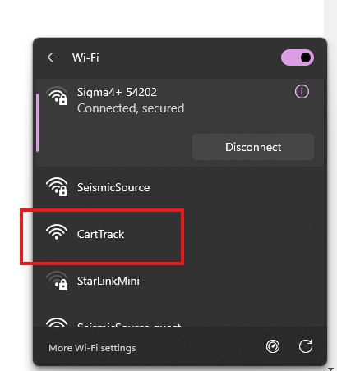 | Power On Cart Track  - Confirm that the Cart Track hardware has been installed on the cart and all required cables are connected.  - Apply power to the Cart Track system.  - Open Wi-Fi or network settings on the phone, tablet, or computer and wait for the Cart Track wireless network to become available on the operator device.

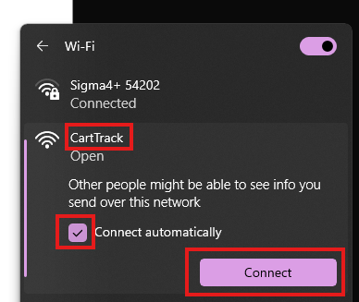 | Connect to the Cart Track Wi-Fi Network  - Select the SSID named Cart Track.  - Choose Connect Automatically and then Connect  - Wait until the device shows that it is connected to the Cart Track network.

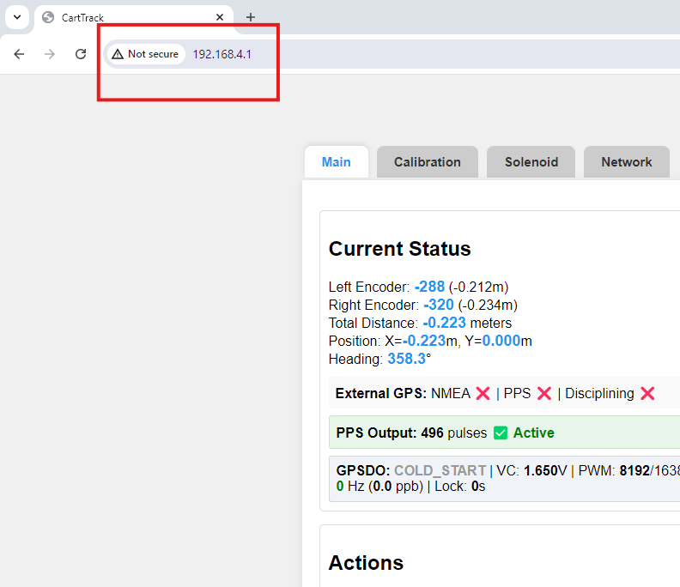 | Open the Configuration Page  - Open a web browser on the connected device.  - Enter 192.168.4.1 in the browser address bar.  - Confirm that the Cart Track configuration interface opens.

Connection note: The Cart Track network is a local configuration network. The connected phone, tablet, or computer will report that internet access is unavailable; this does not necessarily indicate a Cart Track communication problem. You should click the Connect Automatically option in the Wi-Fi network settings to maintain connection to the Cart Track network.

MAIN TAB

Use the Main tab to select the position source used by Cart Track. Choose the mode that matches the work environment.
- ENCODER for indoor use.
- GPS PASSTHROUGH through for outdoor use.

NMEA OUTPUT: ENCODER - INDOOR OPERATION

Encoder mode is intended for indoor cart tracking where live satellite positioning is unavailable or unsuitable. The operator establishes a starting point, and Cart Track uses encoder movement to update the simulated NMEA position.
ENCODER MODE - REFERENCE

Field | Purpose | Operator Notes
Latitude | Starting north/south position for simulated NMEA output. | Enter the confirmed starting latitude or use Fill from GPS.
Longitude | Starting east/west position for simulated NMEA output. | Enter the confirmed starting longitude or use Fill from GPS.
Heading | Initial direction of cart travel. | Enter a known heading when required.
GPS Time | Starting time included in the simulated GPS/NMEA data. | Unedited time is refreshed when Set GPS Point is selected.

Recommended Indoor Workflow
- Position the cart at a known starting point before selecting Set GPS Point.
- Confirm the encoder wheel is in continuous contact with the travel surface.
- Move the cart smoothly and avoid lifting or sliding the encoder wheel.
- Verify the system is receiving NMEA output before beginning the survey line.
- Reset the GPS point whenever the cart is moved to a new known starting location or when accumulated position error requires a new reference.

ENCODER MODE - CONFIGURATION
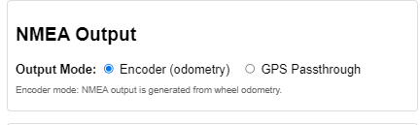 | Select Encoder Mode  - Under the Main tab.  - Select NMEA Output: Encoder (odometry).

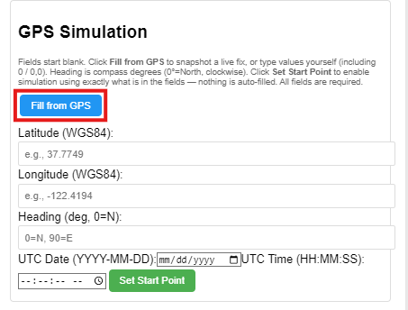 | Load or Enter the Starting Position  - To capture the current live GPS fix, click Fill from GPS under the GPS Simulation option. This copies the current GPS values into the fields below.  - Review the displayed latitude, longitude, heading, time, and any other available fields.  - Edit any field manually when a known survey position or heading must be used.

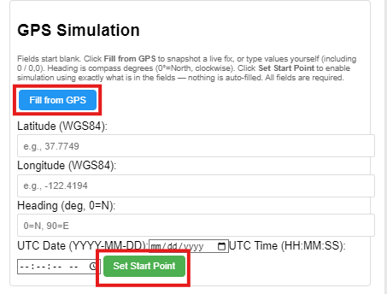 | Set the GPS Point  - Click Set Start Point after reviewing or editing the starting-position fields.  - All fields are required. Use Fill from GPS or enter values manually.  Manual entry: Latitude, longitude, heading, and other available values may be entered manually when the exact starting location is known.

GPS PASSTHROUGH - OUTDOOR OPERATION

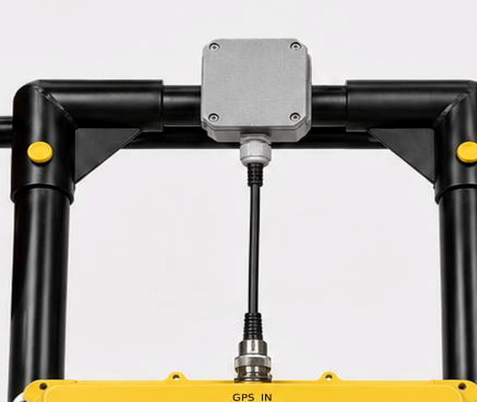 | Prepare the GPS Receiver  - Move the cart to an outdoor area with a clear view of the sky.  - Power the GPS receiver and allow it to obtain a valid position fix.  - Confirm that the GPS receiver is connected to the correct Cart Track input.

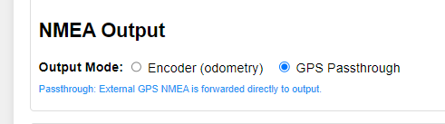 | Select GPS Passthrough  - Connect to the Cart Track SSID and open 192.168.4.1  - Open the Main tab.  - Select GPS Passthrough  External GPS NMEA is forwarded directly to output.

Outdoor operation: GPS accuracy depends on the connected receiver, antenna placement, sky visibility, correction source, and environmental conditions.

POSITION MAP
The Position Map provides a real-time visual display of the cart’s calculated position and movement.
- The red dot shows the cart’s current position.
- The blue trail shows the path traveled by the cart.
- The map automatically updates as encoder or GPS position data is received.
- The Scale value below the map indicates the current map display scale.

ACTIONS
The Actions section provides controls for managing the current tracking session and recorded position data.
- Reset All resets the encoder counts, calculated position, distance, heading, and map data.
- Clear Map removes the displayed position trail without resetting the system’s other values.
- Download CSV downloads the recorded tracking data as a CSV file for review or processing.
  - CSV: latest ~30k samples at 200 ms while moving (rolling, PSRAM)

FIRMWARE UPDATE
Located at the bottom of the Main tab is a space to flash new firmware updates to the Cart Track. Click upload new file and choose only .bin files that are specially for the Cart Track unit. Once the file is uploaded click Upload.
Do NOT power off the unit when uploading new firmware. You can confirm if the Cart Track update worked by checking at the bottom of the page at the Current Version: ______________

Calibration Tab

Use the Calibration tab to configure the measurements Cart Track uses to calculate distance traveled and changes in direction. Complete the rollup calibration first, followed by the wheelbase calibration. Accurate calibration improves the position, distance, heading, and map data displayed by Cart Track.

ROLLUP CALIBRATION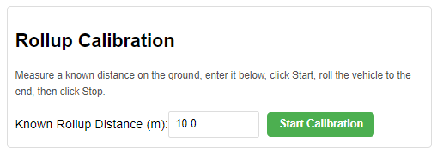
Important: The starting and ending positions must be marked as precisely as possible. Place a straight reference object, such as a stick, rod, or screwdriver, on the ground directly against the same point of the tire at the starting position. After the cart has traveled the measured distance, place the reference object against that same point of the tire at the ending mark. Avoid estimating the tire position by eye. Even a small measurement error can affect the distance-per-count value and reduce the accuracy of all subsequent position, distance, and heading calculations. 10m+ is recommended for more accuracy.

Use Rollup Calibration to determine the distance represented by each encoder count.
1. Measure and mark a known distance on a straight, level surface.
2. Position the cart at the starting mark.
3. Place a stick, rod, or screwdriver on the ground directly against the tire to establish an exact starting reference.
4. Enter the measured distance in Known Rollup Distance (m).
5. Click Start Calibration.
6. Push the cart in a straight line to the ending mark.
7. Stop when the same point of the tire reaches the ending reference.
8. Click Stop when the button appears.
WHEELBASE CALIBRATON
Use Wheelbase Calibration to determine the effective distance between the left and right wheel measurement paths. This value is used to calculate heading and turns.
Complete the rollup calibration before performing this procedure.
- Click Start Wheelbase Cal.
- Push the cart through a closed loop of any shape that returns to the exact starting position and heading.
- Click Stop & Calculate when the button appears.
The loop may be circular, square, or another closed shape. Larger loops generally provide better accuracy. Repeating the procedure several times can improve the final calibration value.

Current Values
The Current Values section displays the calibration values currently being used by Cart Track.
- Distance per Count is the distance represented by one encoder count.
- Counts per Revolution is the number of encoder counts recorded during one complete wheel revolution.
- Distance per Revolution is the calculated distance traveled during one complete wheel revolution.
- Wheelbase is the effective distance between the left and right wheel measurement paths.
These values update after a calibration is completed or a manual value is entered.

Manual Override
Use Manual Override to enter known calibration values without running the automatic calibration procedures.
- Enter a known value in Distance per Count (m) and click Set to apply now. Save to Flash keeps after reboot.
- Enter a known value in Wheelbase (m) and click Set to apply now. Save to Flash keeps after reboot.
Network Tab

Use the Network tab to connect Cart Track to Wi-Fi or Bluetooth to configure optional GPS correction services. NTRIP needs CartTrack connected to a hotspot or router with internet. The CartTrack Wi-Fi network stays available so you can keep this page open while connected.

Wi-Fi (Station)
Use this section to connect Cart Track to a Wi-Fi network with internet access.
- Scan for networks, may take 8-12 seconds
- Select a network
- Enter password
- Click Save & Connect.
- Confirm the status shows connected.

Bluetooth
The Bluetooth section shows whether Cart Track is available for Bluetooth correction data and how many RTCM bytes have been received.
Pair your device with CartTrack using the SSCGNSS Android app to send corrections to the GPS.

NTRIP Client
GPS corrections are optional and are used for improved outdoor positioning accuracy.
Seismic Source offers supported AccuNav NTRIP correction services. Visit store.seismicsource.com for more information or to purchase a subscription. Cart Track may also be used with other compatible NTRIP correction services.
Enter the correction-service information provided by Seismic Source for AccuNav or other NTRIP services:
- Caster host
- Port
- Mountpoint
- Username
- Password

Click Save & Connect to begin receiving GPS corrections. Leave Send GGA every 10s selected when using a VRS service.

External GNSS Tab

Use the External GNSS Tab for viewing GNSS status and changing GNSS baud and data bit settings.

NMEA
The NMEA section displays the live position data received from the external GPS.

- Link shows whether Cart Track is receiving NMEA data.
- Fix type shows the current GPS fix status.
- Satellites shows the number of satellites being used.
- HDOP, PDOP, and VDOP indicate the quality of the satellite geometry.
- Latitude and Longitude show the current position.
- Altitude shows the current elevation.

SSC GNSS
The SSC GNSS section displays additional information when a compatible Seismic Source GNSS receiver is connected.
- Responding confirms communication with the receiver.
- H accuracy shows estimated horizontal accuracy.
- V accuracy shows estimated vertical accuracy.
- Corrections in use shows whether correction data is being applied.
- Galileo HAS shows the status of Galileo High Accuracy Service.
- Constellations lists the satellite systems being used.
- Module, Hardware, and Firmware identify the connected receiver and its installed version.

Settings
Use the Settings section to match Cart Track to the serial settings of the connected GNSS receiver.

- Select the correct Baud rate. The default setting for Seismic Source GPS is 19200 baud
- Select the required Data bits, Parity, and Stop bits.
- Click Apply.
The same serial connection is used for GNSS data and RTCM correction data. The Cart Track settings must match the settings configured in the external GPS receiver.
Solenoid Tab: Only for SeisMike Products

Use the Solenoid tab only with Seismic Source’s SeisMike products equipped with the automatic Solenoid tapping system for concrete and asphalt evaluation. These controls configure when the mechanical tap source fires as the cart moves and how the fire event is synchronized with external recording equipment.
Do not use these settings on a standard Cart Track installation that does not include the SeisMike solenoid and tapping hardware.
Solenoid Control (SSR)
The Solenoid Control section displays the current operating status of the solid-state relay that controls the tapping mechanism.
- Status shows whether the tapping system is idle or actively firing.
- Fire Count shows the number of tap events produced during the current session.
- Distance Traveled shows the distance recorded while the system is operating.
Use these values to confirm that tap events are occurring and to compare the number of taps with the distance traveled.
Pulse Width
The Pulse Width setting controls how long the solid-state relay remains energized for each tap event.
- Enter the desired pulse duration in milliseconds.
- Click Set to apply the value.
A longer pulse keeps the solenoid energized for more time, while a shorter pulse releases it sooner. The correct value depends on the solenoid response and the mechanical tapping assembly.
Important: Use the value recommended by Seismic Source for the installed SeisMike tapping hardware. A pulse width that is too short may not produce a complete tap. A pulse width that is too long may cause unnecessary heating or mechanical stress.

Sync TTL Output
The Sync TTL Output provides a 3.3-volt timing pulse for external equipment, such as a data recorder, camera, or acquisition trigger input. The rising edge of the pulse identifies each tap event.
The connected external device must accept a 3.3 V TTL signal. Connect the grounds of Cart Track and the external device together.
Sync Pulse Width
The Sync Pulse Width controls how long the TTL synchronization signal remains active.
- Enter the desired pulse width in milliseconds.
- Click Set.
This setting normally affects only the synchronization signal and does not change the mechanical duration of the tap.
Pre-start Delay
The Pre-start Delay controls the timing relationship between the synchronization pulse and the solenoid fire event.
- A positive value sends the synchronization pulse first, then fires the solenoid after the entered delay.
- A value of 0 triggers the synchronization pulse and solenoid at approximately the same time.
- A negative value fires the solenoid first, followed by the synchronization pulse after the entered delay.
Use this setting to compensate for delays in the mechanical tap source or connected recording equipment.

Fire Control
The Fire Control section selects how the SeisMike tapping mechanism is activated.
Manual Only
- Select Manual Only when each tap should be initiated by the operator.
- Click FIRE to produce one tap using the configured solenoid pulse width.
- Use this mode during setup, testing, and troubleshooting before enabling automatic firing.

Distance Interval
Select Distance Interval to fire the SeisMike tapping system automatically after the cart travels a set distance.
- Enter the desired spacing in meters.
- Click Set.
- Click Arm Distance Trigger before moving the cart.
- Push the cart forward.
Only forward movement counts toward the programmed distance. The system fires each time the selected distance is reached.
Click Disarm to stop automatic firing. The status beside the buttons shows whether the distance trigger is armed or disarmed.
Using the FIRE button manually resets the accumulated distance for the next automatic tap.

Time Interval
Select Time Interval to fire the tapping mechanism automatically at a fixed time interval.
- Select Time Interval.
- Enter the desired interval in milliseconds.
- Click Set.
This mode fires according to elapsed time rather than distance traveled. It may be used for stationary testing or applications where a constant firing rate is required.

TROUBLESHOOTING AND SUPPORT
Use the table below to identify common Cart Track problems before contacting Seismic Source support.
Issue | Possible Cause | Corrective Action
Cart Track SSID is not visible | Unit is not powered, still starting, or the wireless network is unavailable. | Verify power and cable connections, wait for startup, and refresh the available Wi-Fi networks.
192.168.4.1 does not open | The operator device is not connected to the Cart Track network or has switched to another network. | Reconnect to the Cart Track SSID, select Connect Automatically, and enter 192.168.4.1 directly in the browser address bar.
Position or distance does not update | Encoder mode is not selected, an encoder cable is disconnected, or an encoder wheel is not turning correctly. | Select NMEA Output: Encoder, inspect both encoder cables, and confirm the encoder assemblies turn with the wheels.
Distance or map is inaccurate | Rollup or wheelbase calibration is incorrect, or a wheel slipped or was lifted during operation. | Repeat rollup calibration over 10 m or more, then repeat wheelbase calibration. Keep all encoder wheels in contact with the surface.
Outdoor GPS data is invalid or fixed | The GPS receiver has no valid fix, GPS Passthrough is not selected, or the antenna does not have a clear view of the sky. | Move outdoors, verify the GPS connection and antenna placement, wait for a valid fix, and select GPS Passthrough.
NTRIP corrections do not connect | Wi-Fi internet access, caster information, credentials, or the mountpoint may be incorrect. | Confirm Wi-Fi Station is connected, review the NTRIP settings, and verify that RTCM bytes begin increasing after connection.
SeisMike tap does not fire automatically | The wrong fire mode is selected, the trigger is disarmed, or the pulse/interval settings are not configured. | Select Distance Interval or Time Interval, enter and set the value, arm the trigger, and test once in Manual Only mode.

When Contacting Support:
Record the following information: Cart Track serial number, firmware version, selected operating mode, GPS receiver model, correction service, connected equipment, and a clear description of the problem.
Seismic Source Company | (580) 762-8233 | sales@seismicsource.com | www.seismicsource.com

